NON-COGNITIVE MEASURES

Table of Contents
1 Demographic Questionnaire 3
2 Implicit Theories Of Personality 4
3 Implicit Theories Of Intelligence 5
4 Need For Cognition 5
5 Goal Orientation 5
6 Memory And Reasoning Self Concept 6
7 Big Five Personality 7
8 Self-efficacy scale 8
9 General Self-efficacy scale (1 min) 8
10 Cognitive Failures Questionnaire 9
11 Cognitive Reflection 9
12 Emotional Intelligence 10
13 Narcissism Scale 11
14 The Situational Test of Emotional Understanding 13
15 Situational Test of Emotion Management-Brief (STEM-B) 14
16 Japanese and Caucasian Brief Affect Recognition Test 19
17 Trait Emotional Intelligence Questionnaire—Short Form 20
18 Wong-Law Emotional Intelligence Scale 21
19 Psychological Wellbeing 21
20 Positive and Negative Affect (Self-report) 23
21 Social Media Questionnaire 23
22 Mobile phone questionnaire 23
23 SOCIAL NETWORK SCALE 23
24 Sociability Scale 24
25 Self-Rated Emotional Intelligence Scale 24
26 The Profile of Emotional Competence 25
27 Metacognitive Monitoring Scale 26

Demographic Questionnaire

Instructions
The following information helps us to understand how individual differences in experiences and background influences learning.
- Year of Birth
  - _______
- Gender
  - Male
  - Female
  - Non-binary/Gender diverse
  - Prefer not to say
- Which country do you currently reside in?
- Is English your first language
  - Yes
  - No
    - What language do you speak at home:
      - _____________
    - How long have you been speaking English
      - < 1 year
      - 2-5 years
      - 5-10 years
      - + 10 years
    - How confident are you with your English skills
      - 0 = need assistance when out
      - 100 = proficient and confident
- Your highest level of schooling
  - Primary school
  - Secondary
  - Certificate/Diploma
  - Bachelors degree
  - Masters degree
  - PhD
- Parent 1 - highest level of schooling
  - Primary school
  - Secondary
  - Certificate/Diploma
  - Bachelors degree
  - Masters degree
  - PhD
- Parent 2 - highest level of schooling
  - Primary school
  - Secondary
  - Certificate/Diploma
  - Bachelors degree
  - Masters degree
  - PhD
- Employment
  - Retired (1)
  - Not in paid employment (2)
  - Casual (3)
  - Part-time (4)
  - Full-time (5)
- What is your usual yearly HOUSEHOLD income before tax, from all sources? (please include benefits, pensions, superannuation, etc.)
  - <30K
  - 30-60K
  - 60-90K
  - 90-120K
  - > 120K
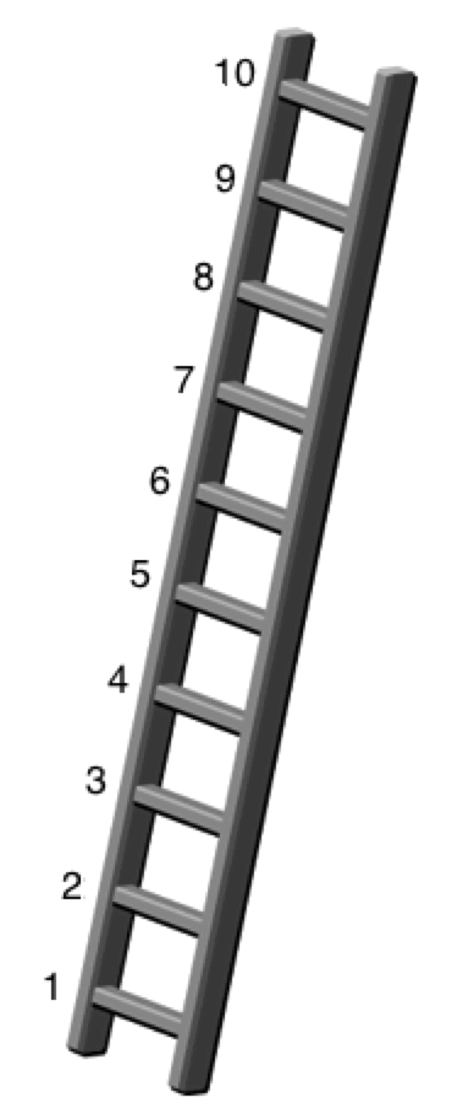
- Think of this ladder as representing where people stand in society. At the top of the ladder are the people who are best off – those who have the most money, most education and the best jobs. At the bottom are the people who are worst off – who have the least money, least education and the worst jobs or no job. The higher up you are on this ladder, the closer you are to people at the very top and the lower you are, the closer you are to the bottom. Where would you put yourself on the ladder?
Please select the number of the rung where you think you stand.
Response options: 1, 2, 3, 4, 5, 6, 7, 8, 9, 10

- Geographic location where you live
  - Urban
  - Suburban
  - Rural
- Rate how often you use the following resources to access information
  - Local library (0=never to 100 = daily)
  - University library (0=never to 100 = daily)
  - Newspapers (0=never to 100 = daily)
  - Internet (online) (0=never to 100 = daily)
  - Friends and family (0=never to 100 = daily)

Implicit Theories Of Personality
Scale
1-100 slider: Strongly Agree to Strongly disagree

Instructions
The following statements deal with your ideas about personality. There are no right or wrong answers. We are interested in your ideas. Read each statement. Using the scale below each statement, please indicate the extent to which you agree or disagree with each statement.

Items
- The kind of person you are, is something very basic about you and it can't be changed very much.
- You can do things differently, but the important parts of who you are can't really be changed.
- You can always substantially change the kind of person you are.
- You can change even your most basic qualities.

Implicit Theories Of Intelligence
Scale
1-100 slider: Strongly Agree to Strongly disagree

Instructions
The following statements deal with your ideas about intelligence. There are no right or wrong answers. We are interested in your ideas. Read each statement. Using the scale below each statement, please indicate the extent to which you agree or disagree with each statement.

Items
- You have a certain amount of intelligence, and you can't really do much to change it.
- No matter who you are, you can significantly change your intelligence level.
- You can learn new things, but you can't really change your basic intelligence.
- No matter how much intelligence you have, you can always change it quite a bit.

Need For Cognition
Scale
1-100 slider: Strongly Agree to Strongly disagree

Instructions
The following statements deal with your preferences in thinking. There are no right or wrong answers. We are interested in your ideas. Read each statement. Using the scale below each statement, please indicate the extent to which you agree or disagree with each statement.
Items
- I would prefer complex to simple problems.
- I like to have responsibility of handling a situation that requires a lot of thinking.
- Thinking is not my idea of fun.
- I would rather do something that requires little thought than something that is sure to challenge my thinking abilities.
- I try to anticipate and avoid situations where there is likely chance I will have to think in depth about something.
- I find satisfaction in deliberating hard and for long hours.
- I only think as hard as I have to.
- I prefer to think about small, daily projects to long-term ones.
- I like tasks that require little thought once I've learned them.
- The idea of relying on thought to make my way to the top appeals to me.
- I really enjoy a task that involves coming up with new solutions to problems.
- Learning new ways to think doesn't excite me very much.
- I prefer my life to be filled with puzzles that I must solve.
- The notion of thinking abstractly is appealing to me.
- I would prefer a task that is intellectual, difficult, and important to one that is somewhat important but does not require much thought.
- I feel relief rather than satisfaction after completing a task that required a lot of mental effort
- It's enough for me that something gets the job done; I don't care how or why it works.
- I usually end up deliberating about issues even when they do not affect me personally.

Goal Orientation
Scal
1-100 slider: Strongly Agree to Strongly disagree

Instructions
The following statements deal with your ideas about goals people pursue at work. There are no right or wrong answers. We are interested in your ideas. Read each statement. Using the scale below each statement, please indicate the extent to which you agree or disagree with each statement.
Items
- I often read materials related to my work to improve my ability.
- I would rather prove my ability on a task that I can do well at than to try a new task.
- I would avoid taking on a new task if there was a chance that I would appear rather incompetent to others.
- I am willing to select a challenging work assignment that I can learn a lot from.
- I am concerned with showing that I can perform better than my co-workers.
- Avoiding a show of low ability is more important to me than learning a new skill
- I often look for opportunities to develop new skills and knowledge.
- I try to figure out what it takes to prove my ability to others at work.
- I am concerned about taking on a task at work if my performance would reveal that I had low ability.
- I enjoy challenging and difficult tasks at work where I'll learn new skills.
- I enjoy it when others at work are aware of how well I am doing.
- I prefer to avoid situations at work where I might perform poorly.
- For me, development of my work ability is important enough to take risks.
- I prefer to work on projects where I can prove my ability to others.
- When I don't understand something at work, I prefer to avoid asking what might appear to others to be "dumb questions" that I should know the answer to already.
- I prefer to work in situations that require a high level of ability and talent

Memory And Reasoning Self Concept
Scale
1-100 slider: Strongly Agree to Strongly disagree

Instructions
In this questionnaire you will be presented with a series of statements which ask you to describe your own abilities, preferences and strategies with respect to reasoning and memory. To respond to the questionnaire, read each statement CAREFULLY and then use the sliding scale below each item to indicate how accurately that statement describes you. The scale ranges from 'Extremely Inaccurate' to 'Extremely Accurate'. Use the values in between to indicate that the statement applies to you to varying degrees.

This is NOT a test - THERE ARE NO 'RIGHT' OR 'WRONG' ANSWERS.
We are interested in how you see yourself. Describe yourself AS YOU ARE NOW - NOT as you think you should be, or how you would like to be in the future. Describe yourself as you GENERALLY or TYPICALLY are.

Try to respond as accurately and honestly as possible. Proceed at your own pace, but DO NOT spend too much time thinking about any one item. The first response that comes to mind is typically the best.

Items
1. My memory is above average. (M)
2. To solve a problem, I rely on reasoning abilities.
3. Compared to other intellectual abilities (i.e., attention, reasoning) my memory is good. (M)
4. I enjoy being involved in activities that require reasoning of some sort.
5. I can remember more material than the average person. (M)
6. I feel confident when solving problems that require reasoning skills.
7. I'm satisfied with my memory. (M)
8. In an exam situation, I get answers right mostly by reasoning.
9. I describe myself as a person with reasoning abilities that are above average.
10. I rely on my memory to get me through exams. (M)
11. I am happy with my reasoning abilities.
12. I enjoy engaging in activities that require me to remember things. (M)
13. I can reason better than the average person.
14. For exam purposes, I memorize material easily. (M)
15. Compared to my other cognitive abilities, my reasoning is sound.
16. I have a good memory. (M)

Big Five Personality
Scale
1-100 slider: Strongly Agree to Strongly disagree

Instructions
You will now be presented with phrases describing people's behaviours. Please use the rating scale next to each phrase to describe how accurately each statement describes you. Describe yourself as you generally are now, not as you wish to be in the future. Describe yourself as you honestly see yourself, in relation to other people you know of the same sex as you are, and roughly your same age. So that you can describe yourself in an honest manner your responses will be kept in absolute confidence. Please read each statement carefully, and then indicate the accuracy of the statement.

Items
- Often feel blue.
- Feel comfortable around people.
- Believe in the importance of art.
- Have a good word for everyone.
- Am always prepared.
- Dislike myself.
- Make friends easily.
- Have a vivid imagination.
- Believe that others have good intentions.
- Pay attention to details.
- Am often down in the dumps.
- Am skilled in handling social situations.
- Tend to vote for progressive political candidates.
- Respect others.
- Get chores done right away.
- Have frequent mood swings.
- Am the life of the party.
- Carry the conversation to a higher level.
- Accept people as they are.
- Carry out my plans.
- Panic easily.
- Know how to captivate people.
- Enjoy hearing new ideas.
- Make people feel at ease.
- Make plans and stick to them.
- Rarely get irritated.
- Have little to say.
- Am not interested in abstract ideas.
- Have a sharp tongue.
- Waste my time.
- Seldom feel blue.
- Keep in the background.
- Do not like art.
- Cut others to pieces.
- Find it difficult to get down to work.
- Feel comfortable with myself.
- Would describe my experiences as somewhat dull.
- Avoid philosophical discussions.
- Suspect hidden motives in others.
- Do just enough work to get by.
- Am not easily bothered by things.
- Don't like to draw attention to myself.
- Do not enjoy going to art museums.
- Get back at others.
- Don't see things through.
- Am very pleased with myself.
- Don't talk a lot.
- Tend to vote for conservative political candidates.
- Insult people.
- Shirk my duties.

Self-efficacy scale
Scale
1-100 slider: Extremely confident to Not confident at all

Instructions
The following questions ask about your perceptions of your ability to perform various activities, such as concentrating, multi-tasking, remembering facts, information and everyday cognitive tasks. If you were given a test of your ability to perform each activity, please indicate how confident you are about your ability to perform each of the following activities.

Items
- Watch an interesting movie or read an interesting book.
- Listen to a boring but important lecture.
- Listen to a conversation when there is something else you want to do.
- Listen to a conversation with several people in which the topic is constantly changing.
- Shift your attention back and forth between two activities.
- Stay focused on an activity when you are being distracted by a second activity.
- Finish reading a newspaper article when something more interesting catches your eye.
- Remember names and facts after reading an article about a familiar topic.
- Remember names and facts after reading an article about an unfamiliar topic.
- Remember mobile phone numbers after hearing them just once.
- Remember the names of people you meet briefly for the first time at a party.
- Complete moderately difficult cognitive games and puzzles.

General Self-efficacy scale (1 min)
Scale
1-100 slider: Strongly Agree to Strongly disagree

- I can always manage to solve difficult problems if I try hard enough.
- If someone opposes me, I can find the means and ways to get what I want.
- It is easy for me to stick to may aims and accomplish my goals.
- I am confident that I could deal efficiently with unexpected events.
- Thanks to my resourcefulness, I know how to handle unforeseen situations.
- I can solve most problems if I invest the necessary effort.
- I can remain calm when facing difficulties because I can rely on my coping abilities.
- When I am confronted with a problem. I can usually find several solutions.
- If I am in trouble, I can usually think of a solution.
- I can usually handle whatever comes my way.

Cognitive Failures Questionnaire
Scale: 7-point scale -
Very
often
Quite often
Occasionally
Very
rarely
Never
The following questions are about minor mistakes which everyone makes from time to time, but some of which happen more often than others. We want to know how often these things have happened to you in the past 6 months. Please circle the appropriate number.

- Do you read something and find you haven’t been thinking about it and must read it again?
- Do you find you forget why you went from one part of the house to the other?
- Do you fail to notice signposts on the road?
- Do you find you confuse right and left when giving directions?
- Do you bump into people?
- Do you find you forget whether you’ve turned off a light or a fire or locked the door?
- Do you fail to listen to people’s names when you are meeting them?
- Do you say something and realize afterwards that it might be taken as insulting?
- Do you fail to hear people speaking to you when you are doing something else?
- Do you lose your temper and regret it?
- Do you leave important letters unanswered for days?
- Do you find you forget which way to turn on a road you know well but rarely use?
- Do you fail to see what you want in a supermarket (although it’s there)?
- Do you find yourself suddenly wondering whether you’ve used a word correctly?
- Do you have trouble making up your mind?
- Do you find you forget appointments?
- Do you forget where you put something like a newspaper or a book?
- Do you find you accidentally throw away the thing you want and keep what you meant to throw away – as in the example of throwing away the matchbox and putting the used match in your pocket?
- Do you daydream when you ought to be listening to something?
- Do you find you forget people’s names?
- Do you start doing one thing at home and get distracted into doing something else (unintentionally)?
- Do you find you can’t quite remember something although it’s “on the tip of your tongue”?
- Do you find you forget what you came to the shops to buy?
- Do you drop things?
- Do you find you can’t think of anything to say?

Cognitive Reflection
*Free response

- A bat and a ball cost $1.10 in total. The bat costs $1.00 more than the ball. How much does the ball cost?
- If it takes 5 machines 5 minutes to make 5 widgets, how long would it take 100 machines to make 100 widgets?
- In a lake, there is a patch of lily pads. Every day, the patch doubles in size. If it takes 48 days for the patch to cover the entire lake, how long would it take for the patch to cover half of the lake?

Emotional Intelligence

The Mayer-Salovey-Caruso Emotional Intelligence Test (MSCEIT)
Mayer, J. D., Salovey, P., Caruso, D. R., & Sitarenios, G. (2003). Measuring Emotional Intelligence With the MSCEIT V2.0. Emotion, 3, 97-105.

The test takes 35-40 minutes to complete and consists of 141 items. There are four types of items, representing: (1) Identifying emotions; (2) Using emotions; (3) Understanding emotions; and (4) Managing emotions. An example item of each type is provided below.
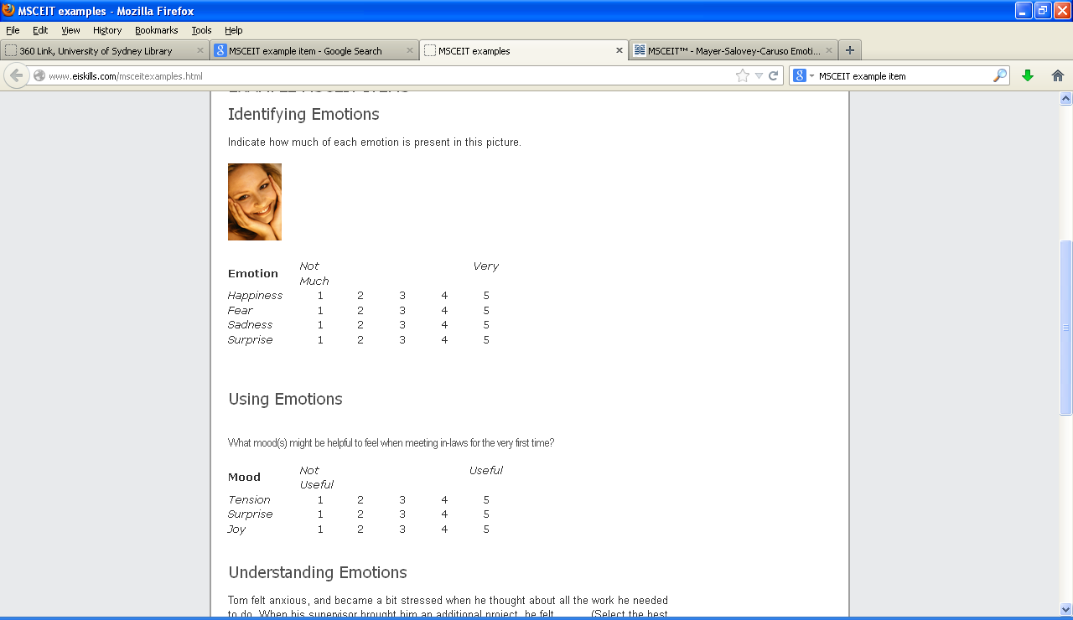


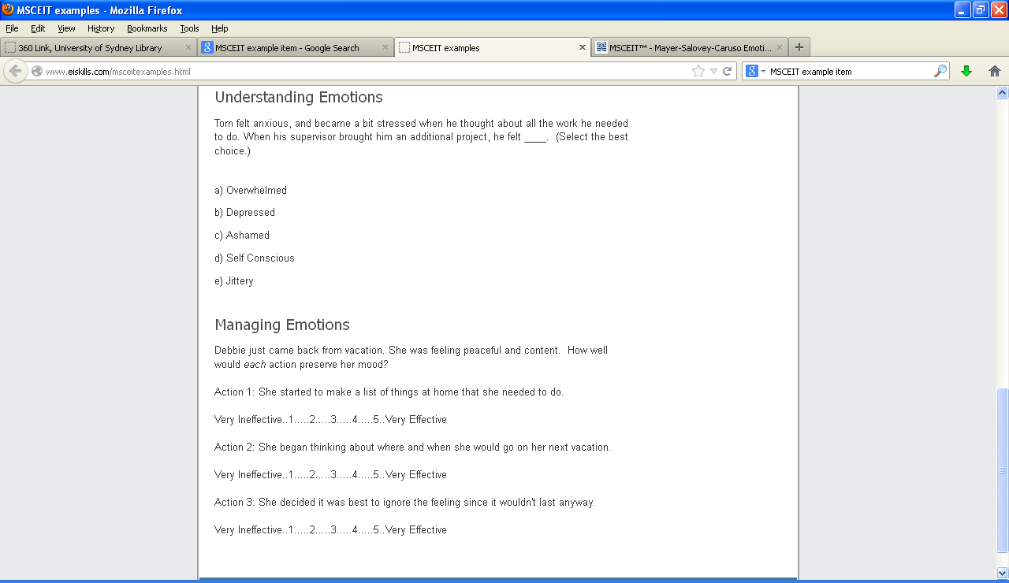


Narcissism Scale
Scale
1-100 slider: Strongly Agree to Strongly disagree

Grandiosity
Exploitativeness
4. I can usually talk my way out of anything.
10. I can make anyone believe anything I want them to.
15. I find it easy to manipulate people.
23. I can read people like a book.
Self-Sacrificing Self-Enhancement
22. I feel important when others rely on me.
25. Sacrificing for others makes me the better person.
33. I like to have friends who rely on me because it makes me feel important.
39. I try to show what a good person I am through my sacrifices.
Grandiose Fantasy
26. I often fantasize about accomplishing things that are probably beyond my means.
31. I often fantasize about being rewarded for my efforts.
42. I often fantasize about performing heroic deeds.
45. I often fantasize about being recognized for my accomplishments.
Vulnerability
Contingent Self-Esteem
8. When people don’t notice me, I start to feel bad about myself.
30. It’s hard to feel good about myself unless I know other people admire me.
32. I am preoccupied with thoughts and concerns that most people are not interested in me.
36. It’s hard for me to feel good about myself unless I know other people like me.
Hiding the Self
9. I often hide my needs for fear that others will see me as needy and desperate.
28. It’s hard to show others the weaknesses I feel inside.
46. I can’t stand relying on other people because it makes me feel weak.
50. When others get a glimpse of my needs, I feel anxious and ashamed.
Devaluing
17. Sometimes I avoid people because I’m concerned that they’ll disappoint me.
21. When others don’t meet my expectations, I often feel ashamed about what I wanted.
27. Sometimes I avoid people because I’m afraid they won’t do what I want them to do.
34. Sometimes I avoid people because I’m concerned they won’t acknowledge what I do for them.
Entitlement Rage
12. I get annoyed by people who are not interested in what I say or do.
18. I typically get very angry when I’m unable to get what I want from others.
37. It irritates me when people don’t notice how good a person I am.
38. I will never be satisfied until I get all that I deserve.

The Situational Test of Emotional Understanding
The following questions each describe a situation, and ask you to choose which of five emotions is most likely to result from that situation.

Here is an example:
Clara receives a gift. Clara is most likely to feel?
(a) happy (b) angry (c) frightened (d) bored (e) hungry

If you think Clara would feel happy, you would select option A and then move to the next question. There are 19 questions.

1. Xavier completes a difficult task on time and under budget. Xavier is most likely to feel?
(a) Surprise (b) Pride (c) Relief (d) Hope (e) Joy

2. If the current situation continues, Denise's employer will probably be able to move her job to a location much closer to her home, which she really wants. Denise is most likely to feel?
(a) Distress (b) Joy (c) Surprise (d) Hope (e) Fear

3. Song finds out that a friend of hers has borrowed money from others to pay urgent bills, but has in fact used the money for less serious purposes. Song is most likely to feel?
(a) Anger (b) Excitement (c) Contempt (d) Shame (e) Horror

4. Charles is meeting a friend to see a movie. The friend is very late and they are not in time to make it to the movie. Charles is most likely to feel?
(a) Depressed (b) Frustrated (c) Angry (d) Contemptuous (e) Distressed

5. Someone believes that another person harmed them on purpose. There is not a lot that can be done to make things better. The person involved is most likely to feel?
(a) Dislike (b) Rage (c) Jealousy (d) Surprise (e) Anxiety

6. Jim enjoys spending Saturdays playing with his children in the park. This year they have sporting activities on Saturdays and cannot go to the park with him any more. Jim is most likely to feel?
(a) Angry (b) Sad (c) Frustrated (d) Distressed (e) Ashamed

7. Megan is looking to buy a house. Something happened and she felt regret. What is most likely to have happened?
(a) She didn't make an offer on a house she wanted, and now she is trying to find out if it is too late.
(b) She found a house she liked that she didn't think she would find.
(c) She couldn't make an offer on a house she liked because the bank didn't get her the money in time.
(d) She didn't make an offer on a house she liked and now someone else has bought it.
(e) She made an offer on a house and is waiting to see if it is accepted.

8. Mary was working at her desk. Something happened that caused her to feel surprised. What is most likely to have happened?
(a) Her work-mate told a silly joke.
(b) She was working on a new task she hadn't dealt with before.
(c) She found some results that were different from what she thought they would be.
(d) She realized she would not be able to complete her work.
(e) She had to do a task she didn't normally do at work.

9. Someone thinks that another person has deliberately caused something good to happen to them. They are most likely to feel?
(a) Hope (b) Pride (c) Gratitude (d) Surprise (e) Relief

10. By their own actions, a person reaches a goal they wanted to reach. The person is most likely to feel?
(a) Joy (b) Hope (c) Relief (d) Pride (e) Surprise

11. An unwanted situation becomes less likely or stops altogether. The person involved is most likely to feel?
(a) Regret (b) Hope (c) Joy (d) Sadness (e) Relief

12. Hasad tries to use his new mobile phone. He has always been able to work out how to use different appliances, but he cannot get the phone to function. Hasad is most likely to feel?
(a) Distressed (b) Confused (c) Surprised (d) Relieved (e) Frustrated

13. Dorian's friend is ill and coughs all over him without bothering to turn away or cover his mouth. Dorian is most likely to feel?
(a) Anxiety (b) Dislike (c) Surprise (d) Jealousy (e) Rage

14. Quan and his wife are talking about what happened to them that day. Something happened that caused Quan to feel surprised. What is most likely to have happened?
(a) His wife talked a lot, which did not usually happen.
(b) His wife talked about things that were different to what they usually discussed.
(c) His wife told him that she might have some bad news.
(d) His wife told Quan some news that was not what he thought it would be.
(e) His wife told a funny story.

15. A supervisor who is unpleasant to work for leaves Alfonso's work. Alfonso is most likely to feel?
(a) Joy (b) Hope (c) Regret (d) Relief (e) Sadness

16. The nature of Sara's job changes due to unpredictable factors and she no longer gets to do the portions of her work that she most enjoyed. Sara is most likely to feel?
(a) Ashamed (b) Sad (c) Angry (d) Distressed (e) Frustrated

17. Leila has been unable to sleep well lately and there are no changes in her life that might indicate why. Leila is most likely to feel?
(a) Angry (b) Scared (c) Sad (d) Distressed (e) Guilty

18. Someone believes another person has deliberately caused something good to stop happening to them. However, they feel they can do something about it. They are most likely to feel?
(a) Angry (b) Contemptuous (c) Distress (d) Depressed (e) Frustrated

19. Matthew has been at his current job for six months. Something happened that caused him to feel regret. What is most likely to have happened?
(a) He did not apply for a position he wanted and has found out that someone else less qualified got the job.
(b) He did not apply for a position he wanted and has started looking for a similar position.
(c) He found out that opportunities for promotion have dried up.
(d) He found out that he didn't get a position he thought he would get.
(e) He didn't hear about a position he could have applied for and now it is too late.

Situational Test of Emotion Management-Brief (STEM-B)
In this test, you will be presented with a few brief details about an emotional situation, and asked to choose from four responses the most effective course of action to manage both the emotions the person is feeling and the problems they face in that situation.

Although more than one course of action might be acceptable, you are asked to choose what you think the most effective response for that person in that situation would be.

Remember, you are not necessarily choosing what you would do, or the nicest thing to do, but choosing the most effective response for that situation.

1. Wai-Hin and Connie have shared an office for years but Wai-Hin gets a new job and Connie loses contact with her. What action would be the most effective for Connie?
(a) Just accept that she is gone and the friendship is over.
(b) Ring Wai-Hin and ask her out for lunch or coffee to catch up.
(c) Contact Wai-Hin and arrange to catch up but also make friends with her replacement.
(d) Spend time getting to know the other people in the office, and strike up new friendships.

2. Manual is only a few years from retirement when he finds out his position will no longer exist, although he will still have a job with a less prestigious role. What action would be the most effective for Manual?
(a) Carefully consider his options and discuss it with his family.
(b) Talk to his boss or the management about it.
(c) Accept the situation, but still feel bitter about it.
(d) Walk out of that job.

3. Surbhi starts a new job where he doesn’t know anyone and finds that no one is particularly friendly. What action would be the most effective for Surbhi?
(a) Have fun with his friends outside of work hours.
(b) Concentrate on doing his work well at the new job.
(c) Make an effort to talk to people and be friendly himself.
(d) Leave the job and find one with a better environment.

4. Andre moves away from the city his friends and family are in. He finds his friends make less effort to keep in contact than he thought they would. What action would be the most effective for Andre?
(a) Try to adjust to life in the new city by joining clubs and activities there.
(b) He should make the effort to contact them, but also try to meet people in his new city.
(c) Let go of his old friends, who have shown themselves to be unreliable.
(d) Tell his friends he is disappointed in them for not contacting him.

5. Clayton has been overseas for a long time and returns to visit his family. So much has changed that Clayton feels left out. What action would be the most effective for Clayton?
(a) Nothing – it will sort itself out soon enough.
(b) Tell his family he feels left out.
(c) Spend time listening and getting involved again.
(d) Reflect that relationships can change with time.

6. Daniel has been accepted for a prestigious position in a different country from his family, who he is close to. He and his wife decide it is worth relocating. What action would be the most effective for Daniel?
(a) Realize he shouldn’t have applied for the job if he didn’t want to leave.
(b) Set up a system for staying in touch, like weekly phone calls or emails.
(c) Think about the great opportunities this change offers.
(d) Don’t take the position.

7. Mei Ling answers the phone and hears that close relatives are in hospital critically ill. What action would be the most effective for Mei Ling?
(a) Let herself cry and express emotion for as long as she feels like.
(b) Speak to other family to calm herself and find out what is happening, then visit the hospital.
(c) There is nothing she can do.
(d) Visit the hospital and ask staff about their condition.

8. Shona has not spoken to her nephew for months, whereas when he was younger they were very close. She rings him but he can only talk for five minutes. What action would be the most effective for Shona?
(a) Realize that he is growing up and might not want to spend so much time with his family any more.
(b) Make plans to drop by and visit him in person and have a good chat.
(c) Understand that relationships change, but keep calling him from time to time.
(d) Be upset about it, but realize there is nothing she can do.

9. Mina and her sister-in-law normally get along quite well, and the sister-in-law regularly baby-sits for her for a small fee. Lately she has also been cleaning away cobwebs, commenting on the mess, which Mina finds insulting. What action would be the most effective for Mina?
(a) Tell her sister-in-law these comments upset her.
(b) Get a new babysitter.
(c) Be grateful her house is being cleaned for free.
(d) Tell her only to baby-sit, not to clean.

10. Juno is fairly sure his company is going down and his job is under threat. It is a large company and nothing official has been said. What action would be the most effective for Juno?
(a) Find out what is happening and discuss his concerns with his family.
(b) Try to keep the company afloat by working harder.
(c) Start applying for other jobs.
(d) Think of these events as an opportunity for a new start.

11. Mallory moves from a small company to a very large one, where there is little personal contact, which she misses. What action would be the most effective for Mallory?
(a) Talk to her workmates, try to create social contacts and make friends.
(b) Start looking for a new job so she can leave that environment.
(c) Just give it time, and things will be okay.
(d) Concentrate on her outside-work friends and colleagues from previous jobs.

12. A demanding client takes up a lot of Jill’s time and then asks to speak to Jill’s boss about her performance. Although Jill’s boss assures her that her performance is fine, Jill feels upset. What action would be the most effective for Jill?
(a) Talk to her friends or workmates about it.
(b) Ignore the incident and move on to her next task.
(c) Calm down by taking deep breaths or going for a short walk.
(d) Think that she has been successful in the past and this client being difficult is not her fault.

13. Blair and Flynn usually go to a cafe after the working week and chat about what’s going on in the company. After Blair’s job is moved to a different section in the company, he stops coming to the cafe. Flynn misses these Friday talks. What action would be the most effective for Flynn?
(a) Go to the cafe or socialize with other workers.
(b) Don’t worry about it, ignore the changes and let Blair be.
(c) Not talk to Blair again.
(d) Invite Blair again, maybe rescheduling for another time.

14. Michelle’s friend Dara is moving overseas to live with her partner. They have been good friends for many years and Dara is unlikely to come back. What action would be the most effective for Michelle?
(a) Forget about Dara.
(b) Spend time with other friends, keeping herself busy.
(c) Think that Dara and her partner will return soon.
(d) Make sure she keeps in contact through email, phone or letter writing.

15. Hannah’s access to essential resources has been delayed and her work is way behind schedule. Her progress report makes no mention of the lack of resources. What action would be the most effective for Hannah?
(a) Explain the lack of resources to her boss or to management.
(b) Learn that she should plan ahead for next time.
(c) Document the lack of resources in her progress report.
(d) Don’t worry about it.

16. Reece’s friend points out that her young children seem to be developing more quickly than Reece's. Reece sees that this is true. What action would be the most effective for Reece?
(a) Talk the issue over with another friend.
(b) Angrily confront her friend about making such statements.
(c) Realize that children develop at different rates.
(d) Talk to a doctor about what the normal rates of development are.

17. Jumah has been working at a new job part-time while he studies. His shift times for the week are changed at the last minute, without consulting him. What action would be the most effective for Jumah?
(a) Refuse to work the new shifts.
(b) Find out if there is some reasonable explanation for the shift changes.
(c) Tell the manager in charge of shifts that he is not happy about it.
(d) Grumpily accept the changes and do the shifts.

18. Julie hasn’t seen Ka for ages and looks forward to their weekend trip away. However, Ka has changed a lot and Julie finds that she is no longer an interesting companion. What action would be the most effective for Julie?
(a) Cancel the trip and go home.
(b) Realize that it is time to give up the friendship and move on.
(c) Understand that people change, so move on, but remember the good times.
(d) Concentrate on her other, more rewarding friendships.

Japanese and Caucasian Brief Affect Recognition Test

Please view the video.

(Examples items only; test cannot be uploaded due to formatting issues)


1.

Which emotion is being displayed?
(a) Happiness (b) Contempt (c) Disgust (d) Sadness (e) Anger (f) Surprise (g) Fear


2.

Which emotion is being displayed?
(a) Happiness (b) Contempt (c) Disgust (d) Sadness (e) Anger (f) Surprise (g) Fear

Trait Emotional Intelligence Questionnaire—Short Form
Please answer each statement below by putting a circle around the number that best reflects your degree of agreement or disagreement with that statement. Do not think too long about the exact meaning of the statements. Work quickly and try to answer as accurately as possible. There are no right or wrong answers.
Completely Disagree |  |  |  |  |  | Completely Agree
1 | 2 | 3 | 4 | 5 | 6 | 7

- Expressing my emotions with words is not a problem for me.
- I often find it difficult to see things from another person’s viewpoint.
- On the whole, I’m a highly motivated person.
- I usually find it difficult to regulate my emotions.
- I generally don’t find life enjoyable.
- I can deal effectively with people.
- I tend to change my mind frequently.
- Many times, I can’t figure out what emotion I'm feeling.
- I feel that I have a number of good qualities.
- I often find it difficult to stand up for my rights.
- I’m usually able to influence the way other people feel.
- On the whole, I have a gloomy perspective on most things.
- Those close to me often complain that I don’t treat them right.
- I often find it difficult to adjust my life according to the circumstances.
- On the whole, I’m able to deal with stress.
- I often find it difficult to show my affection to those close to me.
- I’m normally able to “get into someone’s shoes” and experience their emotions.
- I normally find it difficult to keep myself motivated.
- I’m usually able to find ways to control my emotions when I want to.
- On the whole, I’m pleased with my life.
- I would describe myself as a good negotiator.
- I tend to get involved in things I later wish I could get out of.
- I often pause and think about my feelings.
- I believe I’m full of personal strengths.
- I tend to “back down” even if I know I’m right.
- I don’t seem to have any power at all over other people’s feelings.
- I generally believe that things will work out fine in my life.
- I find it difficult to bond well even with those close to me.
- Generally, I’m able to adapt to new environments.
- Others admire me for being relaxed.

Wong-Law Emotional Intelligence Scale
Indicate the extent to which you agree or disagree to each of the statements.
Strongly Disagree | Disagree | Neither Agree nor Disagree | Agree | Strongly Agree
1 | 2 | 3 | 4 | 5

- I have a good sense of why I feel certain feelings most of the time.
- I have a good understanding of my own emotions.
- I really understand what I feel.
- I always know whether I am happy or not.
- I always know my friends’ emotions from their behaviour.
- I am a good observer of others’ emotions.
- I am sensitive to the feelings and emotions of others.
- I have a good understanding of the emotions of people around me.
- I always set goals for myself and then try my best to achieve them.
- I always tell myself I am a competent person.
- I am a self-motivating person.
- I would always encourage myself to try my best.
- I am able to control my temper so that I can handle difficulties rationally.
- I am quite capable of controlling my own emotions.
- I can always calm down quickly when I am very angry.
- I have good control of my emotions

Psychological Wellbeing
Instructions: Circle one response below each statement to indicate how much you agree or disagree.

Strongly agree | Somewhat agree | Agree a little | Neither agree nor disagree | Disagree a little | Somewhat disagree | Strongly disagree
1 | 2 | 3 | 4 | 5 | 6 | 7

1. I like most parts of my personality.
2. When I look at the story of my life, I am pleased with how things have turned out so far.
3. Some people wander aimlessly through life, but I am not one of them.
4. The demands of everyday life often get me down.
5. In many ways I feel disappointed about my achievements in life.
6. Maintaining close relationships has been difficult and frustrating for me.
7. I live life one day at a time and don't really think about the future.
8. In general, I feel I am in charge of the situation in which I live.
9. I am good at managing the responsibilities of daily life.
10. I sometimes feel as if I've done all there is to do in life.
11. For me, life has been a continuous process of learning, changing, and growth.
12. I think it is important to have new experiences that challenge how I think about myself and the world.
13. People would describe me as a giving person, willing to share my time with others.
14. I gave up trying to make big improvements or changes in my life a long time ago
15. I tend to be influenced by people with strong opinions
16. I have not experienced many warm and trusting relationships with others.
17. I have confidence in my own opinions, even if they are different from the way most other people think.
18. I judge myself by what I think is important, not by the values of what others think is important.

Positive and Negative Affect (Self-report)
Please indicate the extent you felt this way over the LAST DAY/WEEK/MONTH.
Rate how much you felt each emotion from 1 (very slightly or not at all) to 5 (extremely).

- Determined
- Attentive
- Alert
- Inspired
- Active
- Afraid
- Nervous
- Upset
- Ashamed
- Hostile
- Calm
- Content
- Peaceful
- Relaxed

Social Media Questionnaire

- I spend a lot of time thinking about social media apps or planning my use of social media apps
- I feel the need to use social media apps more and more
- I use social media apps so I can forget about my problems
- I’ve tried to use my social media apps less but I can’t
- I’ve become stressed or upset if I am not allowed to use my social media apps
- I use social media apps so much that it has had a bad effect on my schoolwork or job

Mobile phone questionnaire
- I interrupt whatever else I am doing when I am contacted on my phone
- I often use my phone for no particular reason
- I feel connected to others when I am using my phone
- Arguments have arisen with others because of my phone use
- I lose track of how much I am using my phone
- I often think about my phone when I am not using it
- I have been unable to reduce my phone use
- The thought of being without my phone makes me feel distressed

SOCIAL NETWORK SCALE

FAMILY: Considering the people to whom you are related by birth, marriage, adoption, etc…

1. How many relatives do you see or hear from at least once a month?
0 = none 1 = one 2 = two 3 = three or four 4 = five thru eight 5 = nine or more

2. How often do you see or hear from the relative with whom you have the most contact?
0 = less than monthly 1 = monthly 2 = few times a month 3 = weekly 4 = few times a week
5 = daily

3. How many relatives do you feel at ease with that you can talk about private matters?
0 = none 1 = one 2 = two 3 = three or four 4 = five thru eight 5 = nine or more

4. How many relatives do you feel close to such that you could call on them for help?
0 = none 1 = one 2 = two 3 = three or four 4 = five thru eight 5 = nine or more

5. When one of your relatives has an important decision to make, how often do they talk to you about it?
0 = never 1 = seldom 2 = sometimes 3 = often 4 = very often 5 = always

6. How often is one of your relatives available for you to talk to when you have an important decision to make?
0 = never 1 = seldom 2 = sometimes 3 = often 4 = very often 5 = always

FRIENDSHIPS: Considering all of your friends including those who live in your neighborhood…

7. How many of your friends do you see or hear from at least once a month?
0 = none 1 = one 2 = two 3 = three or four 4 = five thru eight 5 = nine or more

8. How often do you see or hear from the friend with whom you have the most contact?
0 = less than monthly 1 = monthly 2 = few times a month 3 = weekly 4 = few times a week
5 = daily

9. How many friends do you feel at ease with that you can talk about private matters?
0 = none 1 = one 2 = two 3 = three or four 4 = five thru eight 5 = nine or more

10. How many friends do you feel close to such that you could call on them for help?
0 = none 1 = one 2 = two 3 = three or four 4 = five thru eight 5 = nine or more

11. When one of your friends has an important decision to make, how often do they talk to you about it?
0 = never 1 = seldom 2 = sometimes 3 = often 4 = very often 5 = always

12. How often is one of your friends available for you to talk to when you have an important decision to make?
0 = never 1 = seldom 2 = sometimes 3 = often 4 = very often 5 = always

Sociability Scale

8 items using 7-point ratings (1 = I disagree completely, 7 = I agree completely).

- I enjoy situations in which I can debate my political views. (Political)
- Spending my free time discussing politics is exciting. (Political)
- A person expressing political opinions draws my attention. (Political)
- I like participating in associations in which all the members may collaborate in order to attain political goals. (Political)
- Thinking about meetings with others is very pleasant for me. (Non Political)
- As soon as I have the chance, I find a way to share time with others in group activities. (Non Political)
- I like meeting with others to plan group activities. (Non Political)
- During vacations, I enjoy doing things with other people. (Non Political)

Self-Rated Emotional Intelligence Scale

- By looking at people’s facial expressions, I recognize the emotions they are experiencing.
- I am a rational person and I rarely, if ever, consult my feelings to make a decision.
- I have a rich vocabulary to describe my emotions.
- I have problems dealing with my feelings of anger.
- When someone I know is in a bad mood, I can help the person calm down and feel better quickly.
- I am aware of the nonverbal messages other people send.
- When making decisions, I listen to my feelings to see if the decision feels right.
- I could easily write a lot of synonyms for emotion words like happiness or sadness.
- I can handle stressful situations without getting too nervous.
- I know the strategies to make or improve other people’s moods.
- I can tell when a person is lying to me by looking at his or her facial expression.
- I am a rational person and don’t like to rely on my feelings to make decisions.
- I have the vocabulary to describe how most emotions progress from simple to complex feelings.
- I am able to handle most upsetting problems.
- I am not very good at helping others to feel better when they are feeling down or angry.
- My quick impressions of what people are feeling are usually wrong.
- My “feelings” vocabulary is probably better than most other persons’ “feelings” vocabularies.
- I know how to keep calm in difficult or stressful situations.
- I am the type of person to whom others go when they need help with a difficult situation.

The Profile of Emotional Competence

1. As my emotions arise I don't understand where they come from.
2. I don't always understand why I respond in the way I do.
3. If I wanted, I could easily influence other people's emotions to achieve what I want.
4. I know what to do to win people over to my cause.
5. I am often a loss to understand other people's emotional responses.
6. When I feel good, I can easily tell whether it is due to being proud of myself, happy or relaxed.
7. I can tell whether a person is angry, sad or happy even if they don't talk to me.
8. I am good at describing my feelings.
9. I never base my personal life choices on my emotions.
10. When I am feeling low, I easily make a link between my feelings and a situation that affected me.
11. I can easily get what I want from others.
12. I easily manage to calm myself down after a difficult experience.
13. I can easily explain the emotional responses of the people around me.
14. Most of the time I understand why people feel the way they do.
15. When I am sad, I find it easy to cheer myself up.
16. When I am touched by something, I immediately know what I feel.
17. If I dislike something, I manage to say so in a calm manner.
18. I do not understand why the people around me respond the way they do.
19. When I see someone who is stressed or anxious, I can easily calm them down.
20. During an argument I do not know whether I am angry or sad.
21. I use my feelings to improve my choices in life.
22. I try to learn from difficult situations or emotions.
23. Other people tend to confide in me about personal issues.
24. My emotions inform me about changes I should make in my life.
25. I find it difficult to explain my feelings to others even if I want to.
26. I don't always understand why I am stressed.
27. If someone came to me in tears, I would not know what to do.
28. I find it difficult to listen to people who are complaining.
29. I often take the wrong attitude to people because I was not aware of their emotional state.
30. I am good at sensing what others are feeling.
31. I feel uncomfortable if people tell me about their problems, so I try to avoid it.
32. I know what to do to motivate people.
33. I am good at lifting other people's spirits.
34. I find it difficult to establish a link between a person's response and their personal circumstances.
35. I am usually able to influence the way other people feel.
36. If I wanted, I could easily make someone feel uneasy.
37. I find it difficult to handle my emotions.
38. The people around me tell me I don't express my feelings openly.
39. When I am angry, I find it easy to calm myself down.
40. I am often surprised by people's responses because I was not aware they were in a bad mood.
41. My feelings help me to focus on what is important to me.
42. Others don't accept the way I express my emotions.
43. When I am sad, I often don't know why.
44. Quite often I am not aware of people's emotional state.
45. Other people tell me I make a good confidant.
46. I feel uneasy when other people tell me about something that is difficult for them.
47. When I am confronted with an angry person, I can easily calm them down.
48. I am aware of my emotions as soon as they arise.
49. When I am feeling low, I find it difficult to know exactly what kind of emotion it is I am feeling.
50. In a stressful situation I usually think in a way that helps me stay calm.

Metacognitive Monitoring Scale

- I deliberately assess my performance on all tasks
- I evaluate how confident I am after each decision
- When I perform tasks, I keep close track of how well I am doing
- I always assess my performance
- I'm realistic about my capabilities
- I know when I am performing well
- I am aware of my strengths and weaknesses
- I tend to be accurate in my self-assessments

